I want to analyze how dependent major corn and soybean producing states have been on federal subsidies over the past 10 years. Using state level data on yield, commodity prices, land value, rent prices, and total subsidies. I aim to evaluate whether an increase in land asset value and rent correlates with federal subsidy levels. The purpose is to determine if these states have become more finically resilient or dependent on government support after ethanol production boom.
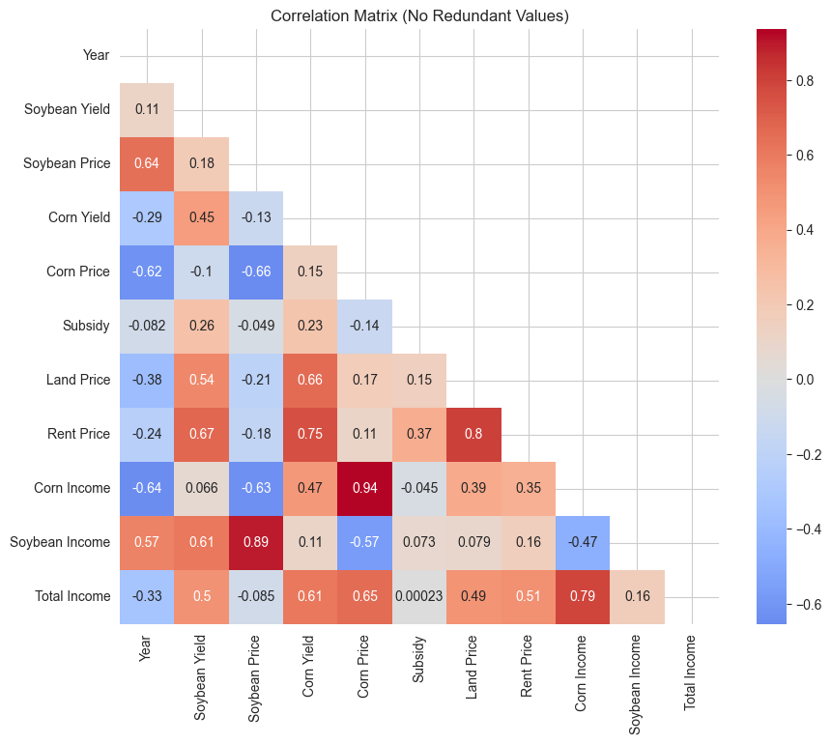
this is an essential visualization showing the driving factors behind each of the categories which really shows the economic state of row crop farming.
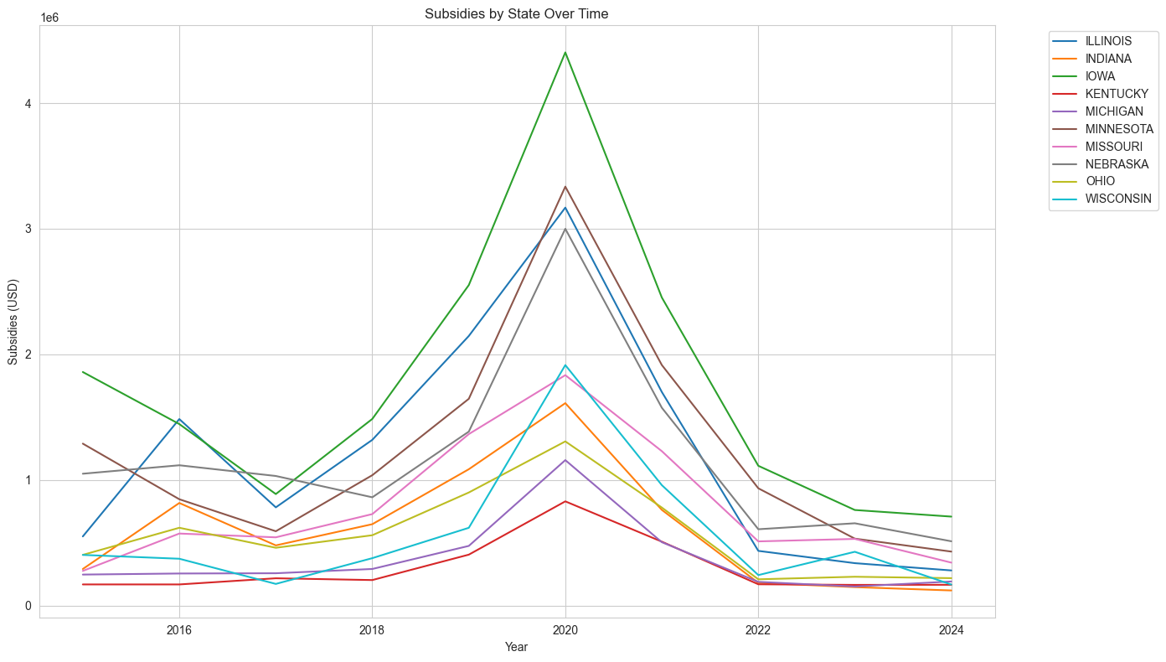
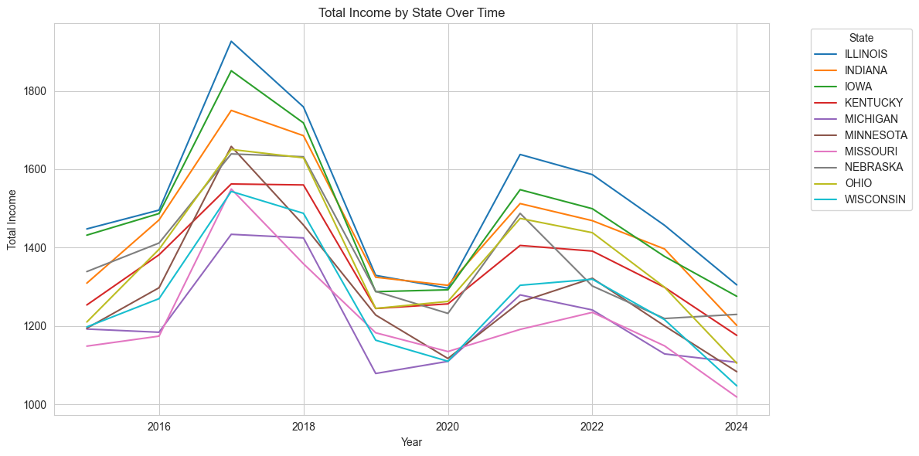
These 2 work together to show how total income which I defined as yield of corn*price of corn + yield of beans*price of beans trends with total subsidies. It also shows a seemingly negative correlation between total income and subsidies. This is important for showing trends.

